DATA SCHEDULING IN CLOUD COMPUTING USING GOOGLE SEARCH ALGORITHM

BY

GROUP FIVE (5)

S/N | NAME | REG. NO
1 | SALIHU MUHAMMAD ABUBAKAR | ND/CS/20/0689
2 | MUSTAPHA BASHIR HASSAN | ND/CS/20/0682
3 | AMINU USMAN | ND/CS/20/0838
4 | KEZIYA ZAKARI | ND/CS/20/0647
5 | KHADIJA BALA | ND/CS/20/0737

SUBMITTED TO THE DEPARTMENT OF COMPUTER SCIENCE, GOMBE STATE POLYTECHNIC BAJOGA IN PARTIAL FULFILLMENT OF THE REQUIREMENT FOR THE AWARD OF NATIONAL DIPLOMA IN COMPUTER SCIENCE

JANUARY, 2023

DECLARATION
We hereby declare that this work is the artifact of our exploration effort, under taken under the supervision of “Mr. Ismail Abdulkarim Adamu” and has not been presented and will not be presented elsewhere for the award of ND certificate in Computer Science. All sources have been duly acknowledged.

S/N | NAME | SIGNATURE | DATE
1 | SALIHU MUHAMMAD
2 | MUSTAPHA BASHIR HASSAN
3 | AMINU USMAN
4 | KEZIYA ZAKARI
5 | KHADIJA BALA

CERTIFICATION
This is to certify that the project titled “Data scheduling in cloud computing using Google search Algorithm” was carried out under the supervision of:

_____________________________ ___________________
Name and Signature Date
(Project Supervisor)

_____________________________ ____________________
Name and Signature Date
(Head of Department)

______________________________ _____________________
Name and Signature Date
(External Examiner)

ACKNOWLEDGMENT
All praise and gratitude is due to Allah (S.W.T), the Creator, the Sustainer, who created the heaven and the earth without pillars and without seeking assistance from anybody may he continuous to bless, mentor our royal model, the best of both jinn and mankind, prophet Muhammad (S.A.W) may salutation of ALLAH be upon him and who gave me courage, wisdom and good health to conduct this project. Special thanks to our project supervisor/HOD Mr. Ismail Abdulkarim Adamu for his thorough assistance with this work, without him this project will never be achievable, we really appreciate your support thank you Sir, and may the almighty ALLAH reward you abundantly.
We also appreciate the good effectiveness and care of the Staff of Computer Science Department for finally extend, we our gratitude to the Computer Science Students (set 2022/2023) for their active verbal participation and suggestions towards the evolvement of this project work.

DEDICATION
We dedicated this project to our beloved parents, friends, brothers and sisters for their thorough assistance financially and advise toward the completion of our studies.

ABSTRACT
Scheduling is the action of assigning resources to perform task. The resources may be processor, network link or expansion cards. Cloud computing is a new technology derived from grid computing and distributed computing and refers to using computing resources (hardware, software, and platforms) as a service and provided to beneficiaries on demand through the Internet. Cloud computing is one of the most important technologies used in recent times, it allows users (individuals and organizations) to access computing resources (software, hardware, and platform) as services remotely through the Internet. The aim of this project is to ensure efficient resource scheduling using Google search algorithm Google search algorithm is a complex system that allows Google to find/investigate, rank and return the most relevant pages for a certain search query. HTML, PHP, JAVASCRIPT, and CSS programming language was used in developing the solution.

Table of Contents
DECLARATION ii
CERTIFICATION iii
ACKNOWLEDGMENT iv
DEDICATION v
CHAPTER ONE 1
1.0 INTRODUCTION 1
1.1 STATEMENT OF THE PROBLEM 3
1.2 AIM AND OBJECTIVES OF THE STUDY 3
1.3 SIGNIFICANCE OF THE STUDY 3
1.4 SCOPE OF THE STUDY 3
1.5 DEFINITION OF TERMS 3
CHAPTER TWO 6
LITERATURE REVIEW 6
2.0 INTRODUCTION 6
2.2 TYPES OF CLOUD SCHEDULING ALGORITHMS 7
2.2.1 FIRST COME FIRST SERVE (FCFS) 7
2.2.2 SHORTEST JOB FIRST (SJF) 8
2.2.3 MAX-MIN 8
2.2.4.1 GOOGLE SEARCH ALGORITHM RANKING FACTORS 9
2.3 CHALLENGES OF CLOUD SCHEDULING 9
2.3.1 Resource Scheduling 10
2.3.2 Autonomic Resource 10
2.3.3 Quality of Service (QoS) 10
2.3.4 Service Level Agreements (SLAs) 10
2.3.5 Self-management Service 10
2.3.6 Energy Management 11
2.3.6 Data Security 11
CHAPTER THREE SYSYTEM ANALYSIS AND DESIGN 12
3.0 Introduction 12
3.1 FACT FINDING TECHNIQUES 12
3.1.1 OBSERVATION METHOD 12
3.1.2 RESEARCH 12
3.2 System Design 13
3.2.1. Google search algorithm 13
3.2.2. Google search API 13
3.2.4. Factors Considered in the Design 13
3.2.5. Flowchart of the Proposed System 14
3.2.6. Data Flow Diagram of the Proposed System 14
3.3 System Design Tools 15
3.3.2 Cascading Style Sheet (CSS) 15
3.3.3. JavaScript 15
3.3.4. HTML 16
3.3.5. VS-Code 16
CHAPTER FOUR 17
SYSTEM INPLEMENTATION AND TESTING 17
4.0 INTRODUCTION 17
4.1 SYSTEM DEVELOPMENT 17
4.2 Software Testing 17
4.3 SOFTWARE IMPLEMENTATION 18
4.4 GUI (Graphical User Interface) 18
4.5 RESULT 18
CHAPTER FIVE 22
5.1 SUMMARY 22
5.2 CONCLUSION 22
5.3 RECOMMENDATION 22
REFERENCE 23
APPENDIX A 24
APPENDIX B 28

CHAPTER ONE

1.0 INTRODUCTION
In past years, the progression of cloud computing has facilitated the high-speed management of interconnected data centers that are distributed geographically for proposing reliable and extraordinary services(Wu, Lu & Zhu, 2016). The pool of interconnected computers that involves several combined computing resources is referred to as the cloud (Arunarani Manjula & Sugumaran, 2019). Cloud computing is a system which is built on the different number of distributed servers, cluster, data storage devices, network infrastructures, different software’s and other coherent practical resources which provides the user with all type of highly manageable computing and storage services. Emerging applications and advancements in cloud computing proposed changes in the IT industry and also clarify the vast complications in the improvement of customary IT (Cheng, Li & Wang, 2015).Cloud computing has grown as an Internet-centered standard model in recent times allowing clients to access according to demands to a united pool of configured resources. Because of this modernization in computing, numerous benefits concerning safety, stack adjusting cost-effectiveness, efficiency, and storage can be perceived. This advancement put forward the computing resources frequently virtualized as facilities for the consumers and hide technical features about resources management (Bittencourt, Madeira & Da Fonseca, 2015).Scheduling is a decision-making procedure that allows resource distribution between several processes by considering their execution command on the set of accessible resources. The scheduler performs the part of selecting a job in which the computational source will complete each job, thus distributing tasks to perform simultaneously in Cloud distributed system. Accordingly, the execution time of all jobs and the execution time of each job is in accordance with the generated schedule. The scheduler arranges the tasks in resource lines generally following an independent framework. Therefore, in cloud computing scheduling plays a significant role to allocate resources to each task proficiently and efficiently (Bittencourt Madeira & Da Fonseca 2018). In a cloud environment, if the jobs are not organized properly, performance decreases and does not provide the outcomes which are supposed to provide as the cloud processes a vast quantity of data. Hence, efficiency-aware scheduling techniques show a dynamic role in cloud computing (Gupta, Kumar & Jana, 2018).The task scheduling complications must be controlled at the virtual machine levels because of the virtualization and commercialization of the cloud environment. In the past decade virtualization technology in cloud computing has modernized and commercialized general-purpose computing applications. Through flexible system configuration, server consolidation, elastic resource provisioning and reduction of operation costs benefits are offered in the cloud model. To competently enhance the functioning of cloud, scheduling is a solitary task completed to advance extreme turnover. In distributed systems, the purpose of scheduling algorithms is the distribution of the load on mainframes processors and takes full advantage while reducing the overall task execution time. The most frequently found objective in the literature review of cloud distributed systems is to reduce the execution time which is attained by a suitable allocation of tasks on the suitable resources (Singh, Tyagi & Kumar, 2020).Internal and external essentials of the resources are set aside and the requirements such as data storage, security, resource expenditures, bandwidth and efficiency regarding time and performance may vary for each job in cloud computing. Security, consistency, and efficiency are the main worries that are noticeable in task scheduling. Henceforth, a secure and efficient scheduling algorithm is mandatory in cloud computing for task and workflow scheduling (Masdari & Zangakani, 2020). Resource scheduling in a cloud environment becomes a challenging task as the total number of clients using cloud services rises. Resource scheduling under a specified cloud environment presents the process of arranging resources based on certain resource usage rules and regulations among the different cloud users. In resource management, the central technology of cloud computing is resource scheduling.

1.1 STATEMENT OF THE PROBLEM
In accordance with the quality of service requirement of the specified applications resource scheduling, the distribution of appropriate resources to the corresponding virtual machine is very challenging. Although researchers have proposed a lot of resource scheduling algorithms still the cloud service providers find it hard to select a suitable algorithm for their implementations. This is because of the interdependencies, dispersion of assets, heterogeneity of resource types, and uncertainty in the cloud environment Arulkumar & Bhalaji (2020). However, the need to implement a suitable algorithm for data scheduling is necessary.

1.2 AIM AND OBJECTIVES OF THE STUDY
The aim of this project is to develop a suitable scheduling algorithm in cloud computing.
Objectives:
- To develop a suitable cloud scheduling algorithm.
- To ensure efficient resource scheduling using Google search algorithm.
- To assess the efficiency of the algorithm.

1.3 SIGNIFICANCE OF THE STUDY
In view of the rapid development of numerous scheduling techniques and algorithms, the need for analyzing and studying these techniques and algorithms is increasing on daily basis. This Project will help cloud service providers select a suitable scheduling for their implementations.

1.4 SCOPE OF THE STUDY
Data scheduling is applicable to almost all field of computing, however this project work focuses on data scheduling in cloud computing.

1.5 DEFINITION OF TERMS
- Cloud: cloud refers to servers that are accessed over the internet and the software and databases that run on those servers.
- Scheduling: Scheduling is the action of assigning resources to perform tasks. The resources may be processors, network links or expansion cards.
- Algorithm: An algorithm is a specific procedure for solving a well-defined computational problem.
- VS-Code editor: Visual Studio Code is a lightweight but powerful source code editor which runs on a desktop and is available for Windows, macOS, and Linux. It comes with built-in support for JavaScript, TypeScript and Node.js and has a rich ecosystem of extensions for other languages (such as C++, C#, Java, Python, PHP, Go) and runtimes (such as .NET and Unity).
- XAMPP: stands for Cross-Platform (X), Apache (A), Maria DB (M), PHP (P), and Perl (P). It is a simple, lightweight Apache distribution that makes it extremely easy for developers to create a local web server for testing and deployment purposes.
- PHP: is a script language and interpreter that is freely available and used primarily on Linux Web servers. PHP originally derived from Personal Home Page Tools now stands for PHP: Hypertext Preprocessor, which the PHP FAQ describes as a "recursive acronym."
- JAVASCRIPT (JS): is a scripting language, primarily used on the Web. It is used to enhance HTML pages and is commonly found embedded in HTML code.
- HTML: is the standard markup language for creating Web pages. HTML (Hypertext Markup Language) is the set of markup symbols or codes inserted in a file intended for display on a World Wide Web browser page. The markup tells the Web browser how to display a Web page's words and images for the user.
- CSS (Cascading Style Sheets): is a style sheet language used for describing the presentation of a document written in a markup language.

CHAPTER TWO

LITERATURE REVIEW

2.0 INTRODUCTION
Cloud computing is a new technology derived from grid computing and distributed computing and refers to using computing resources (hardware, software, and platforms) as a service and provided to beneficiaries on demand through the Internet. Cloud computing is one of the most important technologies used in recent times, it allows users (individuals and organizations) to access computing resources (software, hardware, and platform) as services remotely through the Internet. Cloud computing is distinguished from traditional computing paradigms by its scalability, adjustable costs, accessibility, reliability, and on-demand pay-as-you-go services. As cloud computing is serving millions of users simultaneously, it must have the ability to meet all users requests with high performance and guarantee of quality of service (QoS). Tasks scheduling algorithms are defined as a set of rules and policies used to assign tasks to the suitable resources (CPU, memory, and bandwidth) to get the highest level possible of performance and resources utilization. Task scheduling problem is the one of the most critical issues in cloud computing environment because cloud performance depends mainly on it. There are various types of scheduling algorithms; some of them are static scheduling algorithms that are considered suitable for small or medium scale cloud computing; and dynamic scheduling algorithms that are considered suitable for large scale cloud computing environments. Figure 1. Below shows how resource is schedule over the cloud.
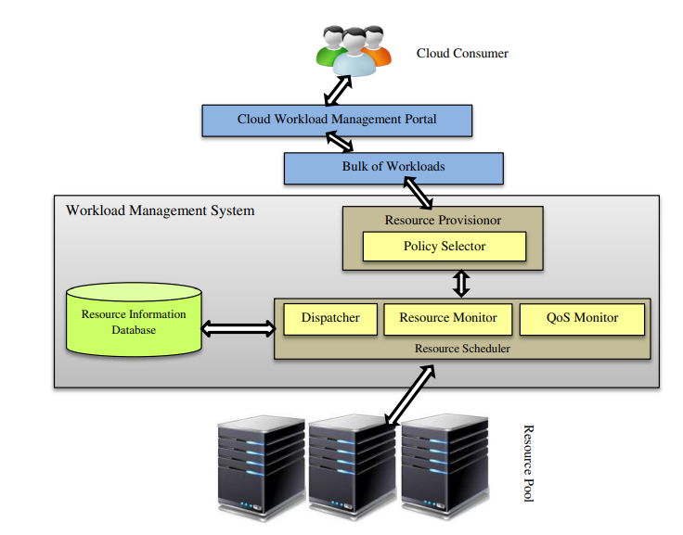
Figure 1: Resource scheduling in cloud computing

2.2 TYPES OF CLOUD SCHEDULING ALGORITHMS
There are varieties of cloud scheduling algorithms as follows:

2.2.1 FIRST COME FIRST SERVE (FCFS)
First Come First Serve: Are the types of scheduling algorithm used by operating system and networks to efficiently and automatically execute queued task, processes and request by the order of arrival. An FCFS scheduling algorithm may also be referred to as first in, first out (FIFO) algorithm or a first come, first choice (FCFC) algorithm.
ADVANTAGES OF FIRST COME FIRST SERVE (FCFS)
- Most popular and simplest scheduling algorithm.
- Fairer than other simple scheduling algorithms.
- Depend on FIFO rule in scheduling task.
- Less complexity than other scheduling algorithms.
DISADVANTAGES OF FIRST COME FIRST SERVE (FCFC)
- Tasks have high waiting time.
- Not giving any priority to tasks.
- Resources are not consumed in an optimal manner.

2.2.2 SHORTEST JOB FIRST (SJF)
Shortest Job First is an algorithm in which the process having the smallest execution time is chosen for the next execution. This scheduling method can be preemptive or non-preemptive. It significantly reduces the average waiting time for other processes awaiting execution. Shortest Job First is shortened as SJF. In SJF tasks are sorted based on their priority. Priority is given to tasks based on tasks lengths and begins from (smallest task ≡ highest priority).
ADVANTAGES OF SHORTEST JOB FIRST (SJF)
- Wait time is lower than FCFS.
- SJF has minimum average waiting time among all tasks scheduling algorithms.
DISADVANTAGES OF SHORTEST JOB FIRST (SJF)
- Unfairness to some tasks when tasks are assigned to VM, due to the long tasks tending to be left waiting in the task list while small tasks are assigned to VM.
- Taking long execution time and TFT.

2.2.3 MAX-MIN
In MAX-MIN tasks are sorted based on the completion time of tasks; long tasks that take more completion time have the highest priority. Then assigned to the VM with minimum overall execution time in VMs list.
ADVANTAGES OF MAX-MIN
- Working to exploit the available resources in an efficient manner.
- This algorithm has better performance than the FCFS, SJF, and MIN-MIN algorithm.
DISADVANTAGES MAX-MIN
- Increase waiting time to small and medium tasks; if we have six long tasks, in MAX-MIN scheduling algorithm they will take priority in six VMs in VM list, and short tasks must be waiting until the large tasks finish.
- Unfairness to some or most small and medium tasks when tasks are assigned to VM.
2.2.4 GOOGLE’S SEARCH / RANKING ALGORITHM
Google’s search algorithm is easily one of the most influential technologies ever created. With an estimated 5.6 billion Google search per day , it’s safe to say Google has a heavy impact on the world and on your business.
The Google Search/ Google’s ranking Algorithm refers to the process Google uses to rank and schedule the cloud content. It takes into account hundreds of factors, including keyword mentions, usability, and backlinks. Google has multiple search algorithms all working together to return the best results. Google’s algorithm is extremely complex, and how it exactly works is not public information. It’s believed that there are well in excess of 200 ranking factors and nobody knows them all.
Even if they do, it won’t matter because the algorithm is always changing. Google releases updates to its algorithm, on average, six times per day. That’s up to 2,000 times per year.
That said, Google does give hints on how you can rank well in its results.

2.2.4.1 GOOGLE SEARCH ALGORITHM RANKING FACTORS
When you think of a “search algorithm” as it relates to search engine optimization (SEO) the first thing that comes to mind is probably Google’s ranking / scheduling factors. In other words, what is Google looking at when deciding which pages to rank / schedule first and in which order?
The Google’s most prominent ranking factors are:
- Backlinks
- Freshness
- Keyword mentions
- User experience
- Topical authority

2.3 CHALLENGES OF CLOUD SCHEDULING
The following are the challenges of scheduling in cloud computing as outlined by Singh et al. (2016):

2.3.1 Resource Scheduling
The challenges of resource scheduling include dispersion, uncertainty and heterogeneity of resources that are not resolved with traditional resource management mechanisms in cloud environment thus; there is a need to make cloud services and cloud-oriented applications efficient by taking care of these properties of the cloud environment.

2.3.2 Autonomic Resource
Scheduling Autonomic management implies the fact that the service is able to self-manage as per its environment. Autonomic management system is required for dynamic resource provisioning to fulfill the QoS requirements as described by cloud user and to reduce service cost and improve efficiency of the system.

2.3.3 Quality of Service (QoS)
To fulfill the QoS requirements of cloud service, required amount of resources are provisioned by service provider. Based on these QoS requirements, SLA is designed and SLA violations are detected regularly, which further decides the penalty or compensation in case of SLA violation.

2.3.4 Service Level Agreements (SLAs)
There is a need of autonomic cloud infrastructures to fulfill the QoS requirements described by cloud user in terms of SLA and to reduce interaction of cloud consumer with the computing environment.

2.3.5 Self-management Service
The aim of a cloud provider in this case is to assign and release resources from the cloud to fulfill its SLOs (Service Level Objectives), reducing its deployment charge. The proactive method uses forecast demand to occasionally assign resources before resources are required. The reactive method responds to instant demand variations before periodic demand forecast is accessible.

2.3.6 Energy Management
In cloud computing, the improvement in energy efficiency is one of the major problems. A main issue in existing techniques is to attain a decent trade-off between energy savings and application performance.

2.3.6 Data Security
Data security is another open issue in cloud computing. Meanwhile cloud providers usually do not have access to the physical data security system of data centers; cloud provider must depend on the infrastructure provider to attain complete data security. Even for a virtual private cloud, the cloud provider can only identify the security setting distantly, without knowing whether it is completely implemented or not. It is dangerous to form trust procedures at each architectural layer of the cloud.

CHAPTER THREE
SYSYTEM ANALYSIS AND DESIGN

3.0 Introduction
Systems are created to solve problems. System analysis, sometimes called requirement analysis, is the process of gathering information about the current system, identifying its strengths and problems, and analyzing them to produce a concept for the new system. The goal of this analysis stage is to truly understand the requirements for the new system and develop a system concept that addresses them. The aim of system analysis is to ensure that the proper decision is taken during the design of a system. System analysis reveals major problem and the basic operations that generate poor performance in the old system and eliminates the tendency of the proposed system producing the same problem.
The objectives of system analysis include;
- Identifying the user’s need and the problem with the existing system.
- Evaluating the system concept for feasibility.
- Allocating functions to hardware, software, people, database and other system elements.
- Creating a system definition that forms the foundation for subsequent engineering work.

3.1 FACT FINDING TECHNIQUES
There are many fact-finding techniques methods with respect to acquiring information about research work. In carrying out this research work, the methods used are observation and research.

3.1.1 OBSERVATION METHOD
Observation is one of the most successful fact-finding techniques carried out for understanding a system. Using this technique, it is achievable to either participate in or observe a person perform activities to learn about the system.

3.1.2 RESEARCH
A useful fact-finding technique is to research the application or the problem that you are dealing with and want to put within a database. Computer trade journals, reference books, and the Internet are good sources of information that can make available the vast quantity of information on how others have solved similar problems/issues plus whether or not any software packages exist to resolve or even partially solve your current problem.

3.2 System Design
System design is the process of defining the architecture, components, modules, interfaces, and data for a system to satisfy the specified functional requirements. System design is the specification or construction of a technical, computer-based solution for the business requirements identified in system analysis. It gives the overall plan or model of a system consisting of all specification that gives the system its form and structure (i.e. the structural design of the system analysis).

3.2.1. Google search algorithm
Google search algorithm refers to the process Google uses to rank content. It is easily one of the most influential technologies ever created. With an estimated 5.6 billion Google searches per day, it’s safe to say Google has a heavy impact on the world and on your business.

3.2.2. Google search API
Google search API is designed to make it easier for webmasters and developers to do two things:
- Add a dynamic search box to your site that includes Google web, video, news, map and blog search results.
- Build powerful web apps on top of google search.
3.2.3. The proposed system
Is a complex system that allows Google to find/investigate, rank and return the most relevant pages for a certain search query that is used to fetching the information from the Google data center, ranking them based on the algorithm.

3.2.4. Factors Considered in the Design
The following are the factors put into consideration during the design of the new system;
- A user friendly system.
- A system that is able to consider all given constraints before producing a feasible (roster) output.

3.2.5. Flowchart of the Proposed System
A flowchart is a sequential diagram employed to show the step by step procedures used in performing a task or solving problems. Any computing problem is solved by executing a series of action in specified order. Thus flowchart is used as a control structure that can help to achieve our goal. Below is the flowchart of the system:
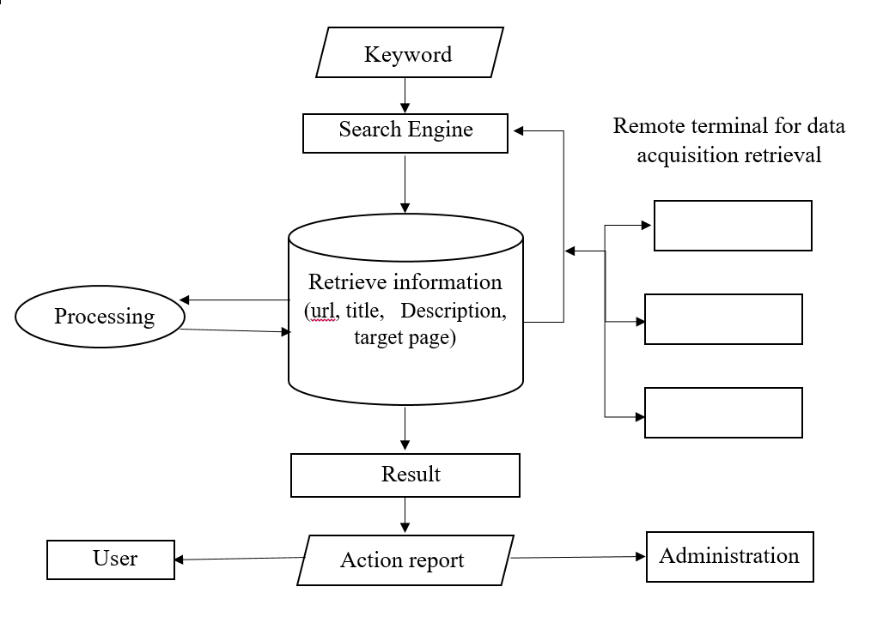
Figure 3.1: Flowchart Diagram of the propose system

3.2.6. Data Flow Diagram of the Proposed System
The data flow diagram is a diagrammatic representation of a system that shows the movement of data from one place to another within the system. They also cover all the processes and data storage area, which takes place during any transaction in the system. The system consist a single Administrator and multiple Users.
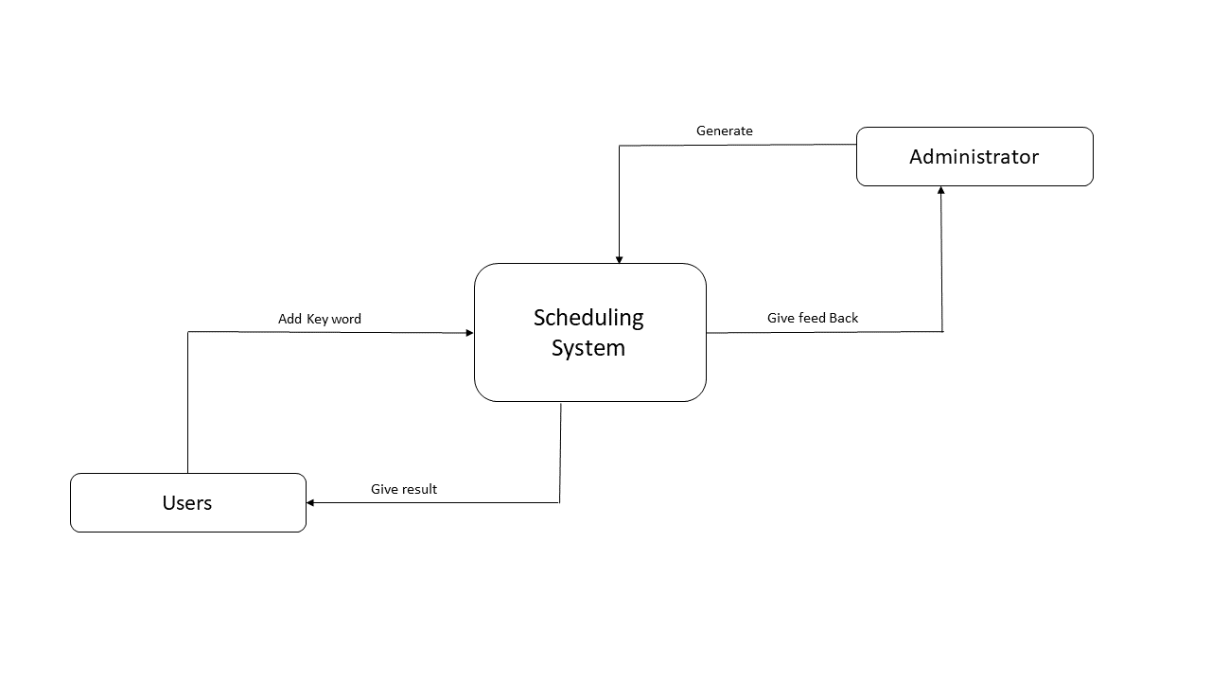
Figure 3.2: Data Flow Diagram of the propose system
3.3 System Design Tools
The programming language and tool used includes HTML, CSS, JavaScript, Google search algorithm, Google API, PHP and Microsoft Visual Studio Code Editor (VS-Code) as the IDE. 3.3.1 Hypertext Preprocessor (PHP)
It is an HTML embedded scripting language for writing or creating dynamic web pages. It allows web developers to create web pages easily in a dynamic way. It is an open-source, programming language. It is used mainly in server-side application software. It is among the most populous programming language in use nowadays. PHP runs on a web server and yields the output to the user as a web page.

3.3.2 Cascading Style Sheet (CSS)
Cascading style sheets are used to format the layout of web pages. They can be used to define text styles, table sizes, and other aspects of web pages that previously could only be defined in a page's HTML. The basic function or use of CSS is to format HTML tags; it has been used in almost the entire site.

3.3.3. JavaScript
JavaScript is a dynamic computer programming language. It is lightweight and most commonly used as a part of web pages, whose implementations allow client-side scripts to interact with the user and make dynamic pages. Its contents are executed without interacting with the server.

3.3.4. HTML
HTML is the standard markup language for creating Web pages. HTML (Hypertext Markup Language) is the set of markup symbols or codes inserted in a file intended for display on a World Wide Web browser page. The markup tells the Web browser how to display a Web page's words and images for the user.

3.3.5. VS-Code
VS-Code editor: Visual Studio Code is a lightweight but powerful source code editor which runs on a desktop and is available for Windows, macOS, and Linux. It comes with built-in support for JavaScript, TypeScript and Node.js and has a rich ecosystem of extensions for other languages (such as C++, C#, Java, Python, PHP, Go) and runtimes (such as .NET and Unity).

CHAPTER FOUR

SYSTEM INPLEMENTATION AND TESTING

4.0 INTRODUCTION
System Implementation is a process that converts the system requirements and design into program codes. This phase at time involves some modification to the previous design and describes how the initial and revised process design is put into a real working system. Therefore, huge effort will be spent in this phase to determine the success of the system and ease the process of modification, debugging, testing, verification, system integration and for future enhancement. This chapter puts a proposed system into action and examines in details the implementation of the system. The implementation of this new system, highlighting the testing exercise and describing some of the main components of the system's Graphical User Interface (GUI).

4.1 SYSTEM DEVELOPMENT
In this phase, the actual code will be delivered as the running system that will be put into operation. Each module developed in this proposed system, before it is being delivered to the next phase should be tested.
This system was developed using HTML (Hypertext Markup Language), CSS (Cascading Style Sheet), PHP (Hypertext Preprocessor), JS (JavaScript) and XAMPP Server as local host or Framework to test the functionality of the proposed system.

4.2 Software Testing
Software Testing is evaluation of the software against requirements gathered from users and system specifications. Testing is conducted at the phase level in software development life cycle or at module level in program code. Software testing comprises of Validation and Verification. In addition, software testing is a critical element of software quality assurance and represents ultimate review of specification, design and implementation phases.
There are steps that involve in system testing which are:
- Unit testing: While coding, the programmer performs some tests on that unit of program to know if it is error free. It helps developers decide that individual units of the program are working as per requirement and are error free.
- Integration testing: Even if the units of software are working fine individually, there is a need to find out if the units if integrated together would also work without errors. For example, argument passing and data updating.
- Acceptance testing: When the software is ready to hand over to the client, it has to go through last phase of testing where it is tested for user-interaction and response. This is important because even if the software matches all user requirements and if user does not like the way it appears or works, it may be rejected. There are steps that involve in system testing which are:
- Alpha testing: The team of developer themselves perform alpha testing by using the system as if it is being used in work environment.
- Beta testing: After the software is tested internally, it is handed over to the users to use it under their production environment only for testing purpose.

4.3 SOFTWARE IMPLEMENTATION
Software Implementation is a systematically structured approach to effectively integrate software-based service or component into the workflow of an organizational structure or an individual end-user. System implementation takes place when the proposed system is realized after which the proposed system is tested and found to be working properly and error-free.

4.4 GUI (Graphical User Interface)
The presentation is based on the interface of the system and the outputs from the back end and the application interfaces consist of various windows that enable different categories of users to interact with the system. This includes the Home page, user pages, administrative pages and their respective outputs.

4.5 RESULT
Below are some of the results of the developed system below.
Figure 4.1: First page of the system: Is the first page that will display with allows users to search the meaning, explanation, description of a desired word.
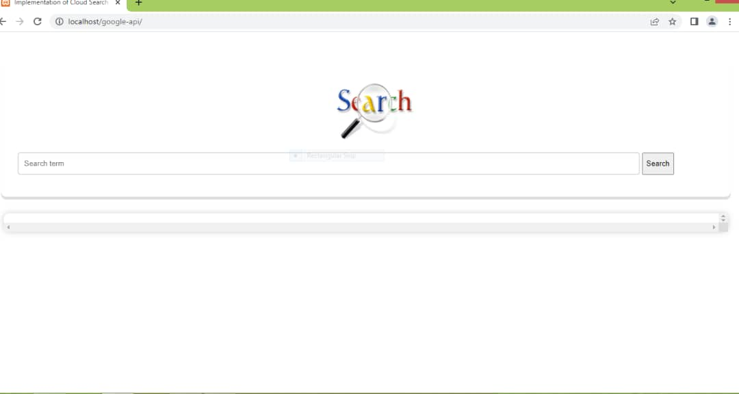
Figure 4.1: Is the homepage of the system.

Figure 4.2:
shows the result of a numerical search.

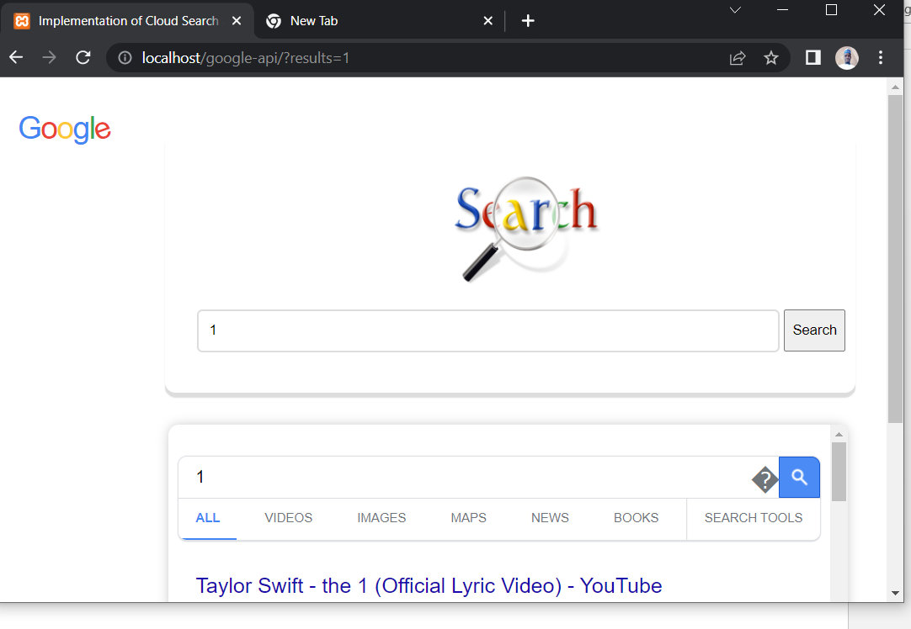
Figure 4.2:
The result of the numerical search (1).

Figure 4.3:
showing the result of a searched word (Computer).
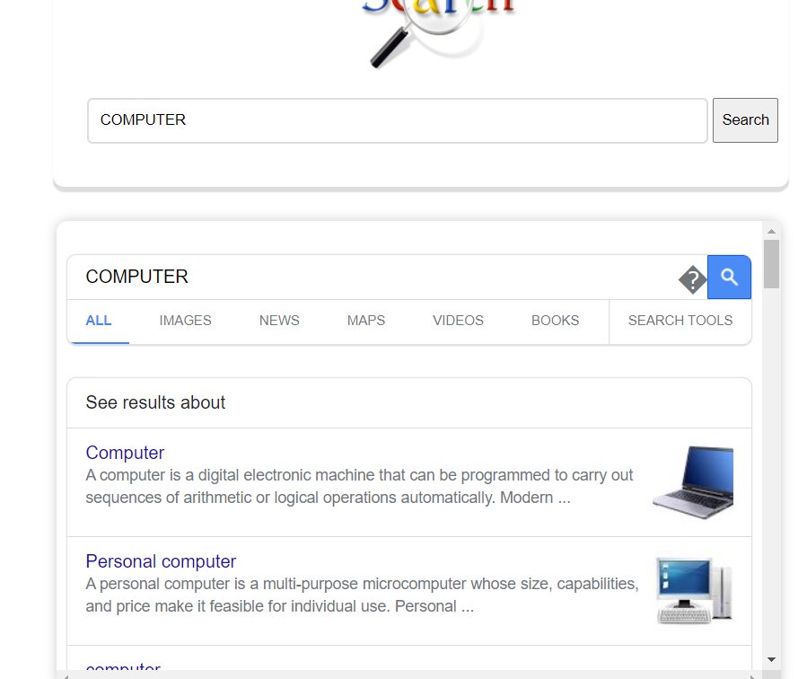
Figure 4.3:
The output result of searched word (computer).

Figure 4.4:
Is the output of Gombe State Polytechnic Bajoga search.


Figure 4.4:
Is the result of Polytechnic Bajoga search.

CHAPTER FIVE

5.1 SUMMARY
The use of computer software is more than necessary in this modern day. The aims and objectives of this study were achieved using a combination of techniques. The problem statement shows absence of an efficient scheduling algorithm.
With the implementation of a new system, the researcher found out that, if the scheduling algorithm is effectively used, it can have a positive impact on the quality of operations of the data scheduling in cloud computing.

5.2 CONCLUSION
The objectives of the study were achieved and the system that has been designed will enable the users to perform their work faster and accurately, reduce the time that have been was in scheduling algorithms and lead to users satisfaction.

5.3 RECOMMENDATION
This Learning Management System (LMS) was developed with the intention of using it in the process of scheduling algorithms. The researcher recommends that if this scheduling algorithm is put to its intended use, it will provide an avenue for proper, efficient and effective data scheduling in cloud computing.

REFERENCE
Cheng C, Li J, Wang Y. 2015. An energy-saving task scheduling strategy based on vacation queuing theory in cloud computing. Tsinghua Science and Technology 20(1):28-39

Bittencourt LF, Madeira ER, Da Fonseca NL. 2015. Resource management and scheduling.

Bittencourt LF, Goldman A, Madeira ER, Da Fonseca NL, Sakellariou R. 2018. Scheduling in distributed systems: a cloud computing perspective. Computer Science Review 30:31-54

Gupta I, Kumar MS, Jana PK. 2018. Efficient workflow scheduling algorithm for cloud computing system: a dynamic priority-based approach. Arabian Journal for Science and Engineering 43(12):7945-7960

Singh H, Tyagi S, Kumar P. 2020. Scheduling in cloud computing environment using meta-heuristic techniques: a survey. In: Emerging Technology in Modelling and Graphics. Singapore: Springer. 753-763

Masdari M, Zangakani M. 2020. Efficient task and workflow scheduling in inter-cloud environments: challenges and opportunities. The Journal of Supercomputing 76(1):499-535

Arulkumar V, Bhalaji N. 2020. Resource scheduling algorithms for cloud computing environment: a literature survey. In: Inventive Communication and Computational Technologies. Berlin: Springer. 1059-1069

Arunarani A, Manjula D, Sugumaran V. 2017. Ffbat: a security and cost-aware workflow scheduling approach combining firefly and bat algorithms. Concurrency and Computation: Practice and Experience 29(24):e4295

Arunarani A, Manjula D, Sugumaran V. 2019. Task scheduling techniques in cloud computing: a literature survey. Future Generation Computer Systems 91:407-415

Wu K, Lu P, Zhu Z. 2016. Distributed online scheduling and routing of multicast-oriented tasks for profit-driven cloud computing. IEEE Communications Letters 20(4):684-687

Singh, S., Chana, I. A Survey on Resource Scheduling in Cloud Computing: Issues and Challenges. J Grid Computing 14, 217–264 (2016). https://doi.org/10.1007/s10723-015-9359-2

APPENDIX A
<?php
// get the search input
$search = $_GET['results'];
// check if user click search button, then
if(isset($_GET['results']) && $_GET['results'] != ""){
// Google API
$url = "https://www.google.com/search?channel=fs&client=&"."q=".str_replace(' ', '%20', $_GET['results']);
// Algorithm implementation using PHP code.
$ch = curl_init();
curl_setopt($ch, CURLOPT_URL, $url);
curl_setopt($ch, CURLOPT_RETURNTRANSFER, 1);
curl_setopt($ch, CURLOPT_REFERER, 'https://www.google.com'); // use google search engine
$body = curl_exec($ch);
curl_close($ch);
}
?>
<!DOCTYPE html>
<html lang="en">
<head>
<meta charset="UTF-8">
<meta http-equiv="X-UA-Compatible" content="IE=edge">
<meta name="viewport" content="width=device-width, initial-scale=1.0">
<link href='http://fonts.googleapis.com/css?family=Yanone+Kaffeesatz' rel='stylesheet' type='text/css'>
<title>Implementation of Cloud Search Algorithm using Google API</title>
<style>
#content{
margin: auto;
width: 96%;
height: 200px;
box-shadow: 0px 5px 1px #ddd;
border-radius: 10px;
margin-top: 50px;
padding-bottom: 50px;
padding-left: 30px;
}
#google_body{
margin: auto;
width: 96%;
max-height: 400px;
box-shadow: 0px 0px 10px #ccc;
border-radius: 10px;
margin-top: 30px;
padding: 7px 10px 10px 10px;
overflow: scroll;
}
#form_input:focus{
border: 2px solid #ddd;
}
#search_button{
height: 40px;
}
#form_input{
border-radius: 5px;
border: 2px solid #ddd;
margin-top:15px;
width: 86%;
height: 35px;
padding-left: 10px;
}
#logo_div{
text-align: center;
padding-top: 40px;
}
#logo{
width: 150px;
height: 110px;

}
</style>
</head>
<body>
<div id="content">
<div id="logo_div"><img src="img/Logo-search.jpg" id="logo" alt=""></div>
<form action="" method="get">
<input type="text" id="form_input" name="results" placeholder="Search term" value="<?php echo $search; ?>"/>
<input type="submit" value="Search" id="search_button"/>
</form>
</div>
<div id="google_body"><?php echo $body; ?></div>
</body>
</html>

APPENDIX B

